**Chair’s report Ann Rostron**

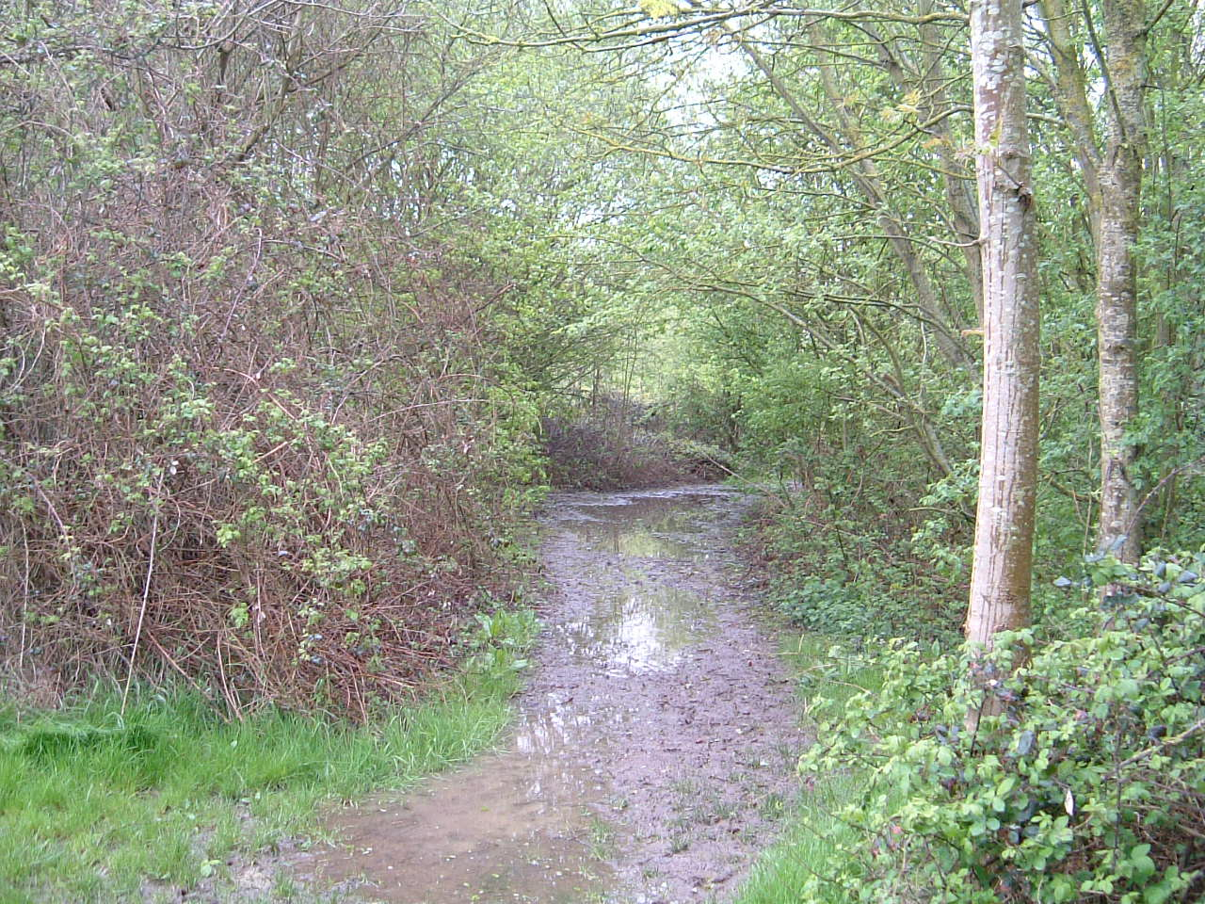As a group, we continually apply for various grants to fund environmental projects in Wymondham. For example, we have recently been lucky enough to receive £452 from the Waitrose Community Matters Fund. We are currently preparing a grant application to the European LEADER Fund for our largest project to date – a new, all-weather surface for the footpath through Kett’s Park Wood – which will cost in the region of £30,000. If funded, the footpath surface will be installed in partnership with the Town Council. The decision on funding is due in December 2018 and if we get the go-ahead, the work will start as soon as the ground is dry enough for machinery to work there (probably late April 2019). For this application, we need to demonstrate that we have local support and we would therefore be very grateful for donations to the fund. These can be made to our Bank Account **Greening Wymondham, reference Kett’s Park, account number 81288168, sort code 30-96-17** or cheques payable to **Greening Wymondham sent to our Treasurer at 26 Whitehorse Street, NR18 0BJ**.

We will be having a stall at the ‘Made in Wymondham’ event in the Market Place on Saturday 14th July, where we will be displaying Greening information, our new posters and selling plants. We will also be selling our new greetings cards featuring our emblem, a hare. Our hare is very appropriate as Henry the GoGo Hare will shortly arrive in Wymondham and will mark the public launch of the Historic Wymondham Trails smartphone App 'Wym Trails', a new, free-to-download App that will enable visitors and residents to experience history through virtual reality.

The roundabout near Waitrose will be planted with flowers in the autumn to a design suggested by members of Greening Wymondham. One to watch out for! We are also advising the Queen Street Baptist Church on planting for their garden to give a sheltered seating area, an improved play space and perennial planting along the side wall and the church. If all goes well, this should be in place by spring next year.

Please let us know if you would like to be kept informed of our programme or have any suggestions for work that we might undertake. We’d love to hear from you by email [greening.wymondham@gmail.com](mailto:greening.wymondham@gmail.com) or on our Facebook page. Have a lovely summer and celebrate our green environment!

**The Mid Norfolk Railway (MNR) Permissive Path**

The MNR path is a 600m stretch of footpath close to the Wymondham Allotments that runs directly beside the Mid Norfolk heritage railway line. It is owned by the MNR who have given permissive access to the general public. It was originally created in 1998 by the late Horace Wilkinson as part of a vision of a larger county walk. It enables a walk from one side of Wymondham through the town and out through open countryside to the Kimberley Hall Estate, a ‘Capability’ Brown designed parkland.

The footpath begins as a spur off part of the Tiffey Valley walk (from Becketswell to Chapel Bell), just past the boardwalk section. Here, through a wooden entrance, it drops down to the rail line and continues beside it, under the B1135 road bridge, beside the allotments and 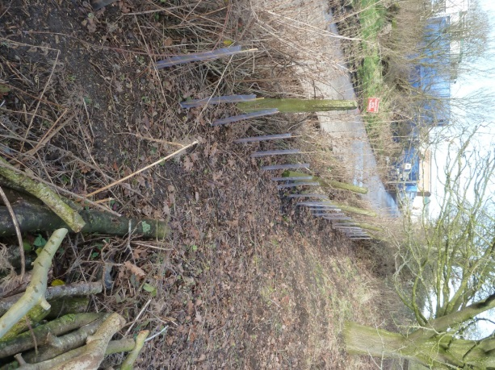sewerage works and then joins a public footpath a few meters further on, as it passes under the railway bridge.

You may not have been aware that last year this small but important section of path was in serious threat of closure. Path clearance by Norfolk County Council had ceased due to budgetary constraints and the MNR, due to their large ongoing infrastructure projects, were not able to divert funds or personnel to maintain it. Thus the MNR were going to close the footpath. This would have been a disaster as it would effectively have severed the Tiffey Valley Walk in two with no practical alternative route to access the Public Rights of Way (PROW) network leading to the Kimberley Estate.

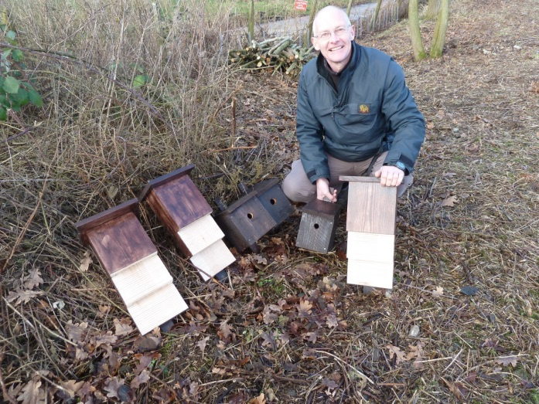Greening Wymondham along with the Wymondham Heritage Society, Wymondham Nature Group, and The Ramblers and Friends of the Tiffey Valley raised a petition to hold a meeting with the MNR. This meeting was chaired by the then Mayor, Robert Savage, and resulted in the MNR agreeing to Greening Wymondham’s proposal to make improvements to the footpath, and take on the management and maintenance to ensure that the path remained open.

Work undertaken by Greening Wymondham so far includes the clearing of vegetation to greatly widen the path, the planting of primroses, native bluebells and hedging. We have also installed bat and bird boxes and planted of a small area of wildflowers.

# ****Environmental Champion of the Year *–***** South Norfolk Community Awards

### *****Graham Moates*****

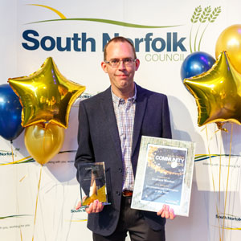Greening Wymondham would like to congratulate one of our new members, Graham Moates, for his recent success in the South Norfolk Community Awards and also thank Graham for donating the £250 prize money to Greening Wymondham! The Community awards celebrate the valuable contribution volunteers make to the district. This year, they received nearly 90 nominations of which nine were winners.

Graham won the Environmental champion award which was sponsored by Smurfit Kappa. Since 2016, Graham has been studying the impact of discarded litter on small mammals in the environment on an entirely self-led, voluntary basis.  This study has since been used to support a national campaign on roadside litter led by Keep Britain Tidy.

Forthcoming events/activities

We have several events planned over the summer/autumn (see below) and look forward to seeing you at some of them.

* Saturday 22rd September: Great Wymondham Litter Pick #2 – 10 to 1pm, Wymondham Football Club.
* The coppicing work in Kett’s Park Wood will be starting again on Tuesday 2 October end then on the first and third Tuesdays through to March 2019.